WefiChat
J. Potgieter

1. Project Overview
WefiChat is a lightweight, real-time messaging tool. The goal is to provide a responsive, single-page application (SPA) experience for individual and group communication.

2. System Architecture
The application follows a standard Client-Server architecture with a persistent connection for real-time updates.
I decided to keep things simple with a vertical slice architecture. Using traditional layers felt like overkill for a chat app of this size, so this way, I can keep all the logic for each feature in one spot without the extra boilerplate.

2.1 Technical Stack
Layer | Technology | Key Responsibility
Frontend | Angular | UI/UX SignalR Client
API | .NET 8 Web API | Authentication, Business Logic, Persistence
Real-time | SignalR | WebSocket management, Message broadcasting
Storage | SQLite + EF Core | Message history, User profiles, Group metadata

Requirements
* 1. Chats stored inside the database, so that if the server is restarted, the chats can be recalled.

* 2. As a user, I should be able to create and delete a channel.

* 3. As a user, I should be able to send a message to a specific channel.

* 4. As a user, I should be able to log in and out of the application.

* 5. Register a new user.

Application overview

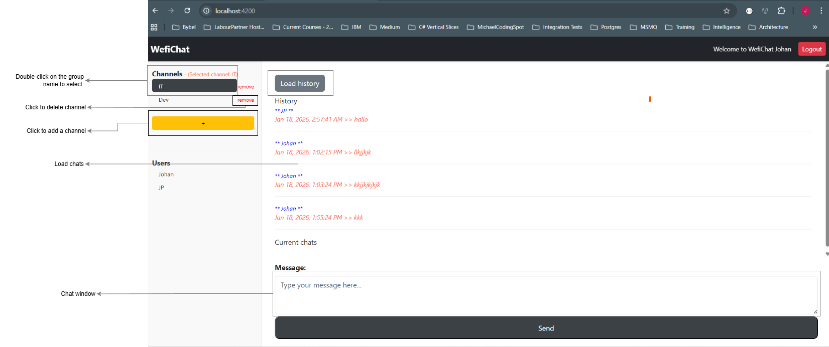
fig 1.

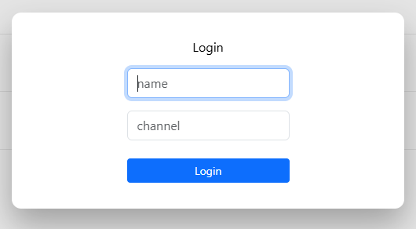

fig 2. Login screen

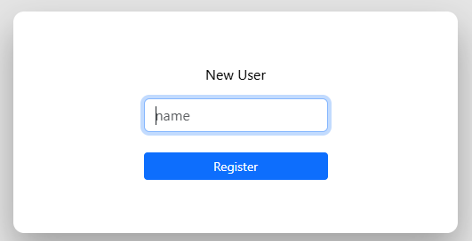

fig 3. Register new user

fig 4. Log out

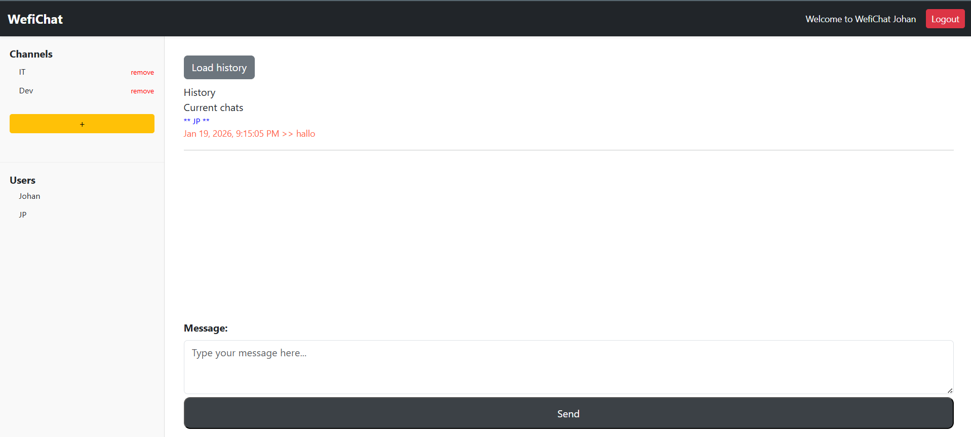
fig 5. Chat session as Johan in chrome. See the name top right corner next to the Logout button.
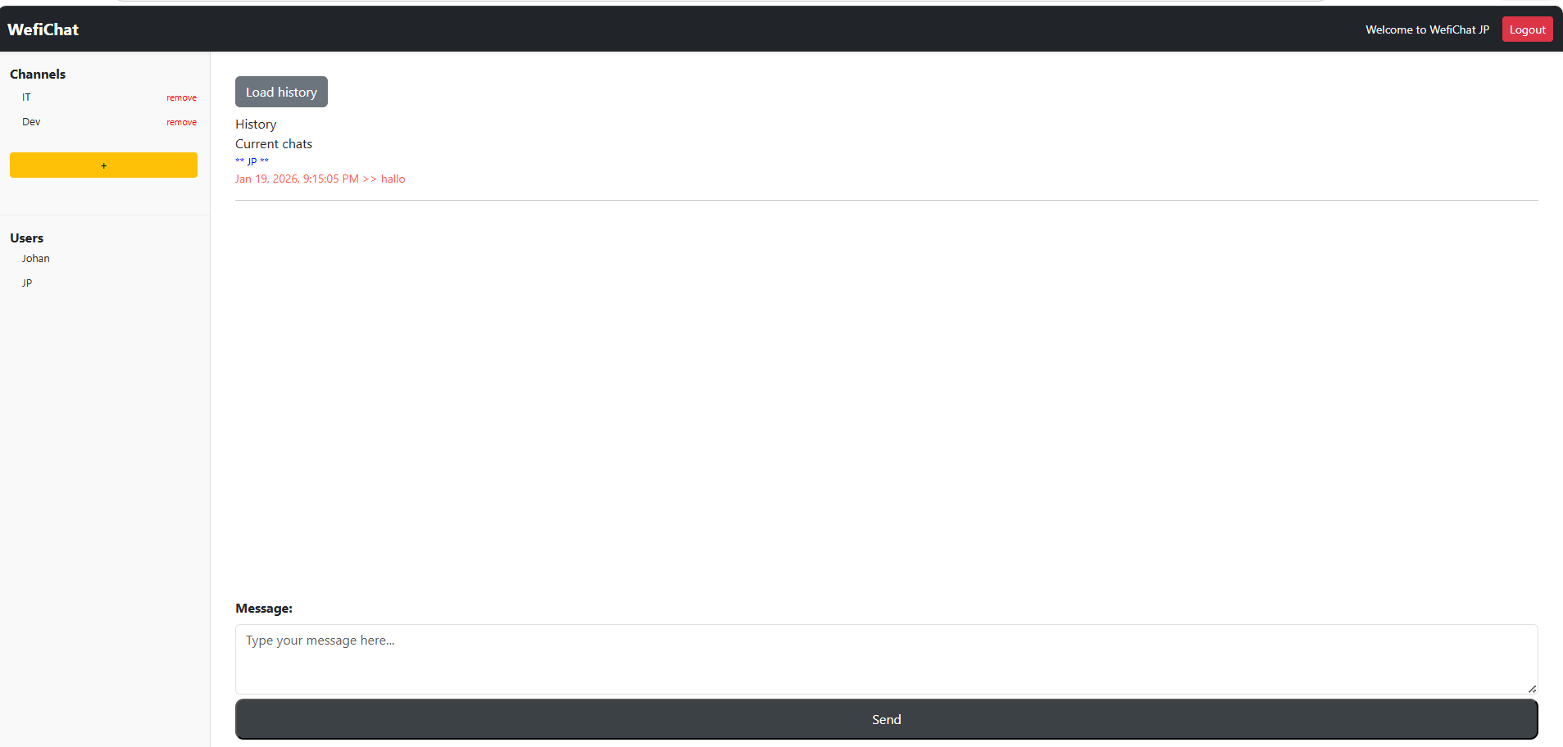

Fig 6. Receiving chat in edge as user JP

fig 7. Login / Register

Steps.
1. Register a new user by clicking on the register button fig 7. Enter your name. (fig 3).

2. If the login window does not appear immediately after registering, click on the login button (fig 7).

3. Enter name and channel. This will set the active user and channel as well as joining a group in SignalR (fig 2).

4. If you want to change channels, double-click a specific channel (fig 1) to join.

5. For chatting, enter text in the message box and click send see fig 1.

6. After chatting, logout will clear the active user. If browser is closed and opened again, the user can continue as the active user.

Validations
Some validations are performed:

1. When registering a new user, the application will check if an existing user already exists.
2. When logging in, check if there is a user with the same name. If the user does not exist an error message is displayed.

Activity Diagram

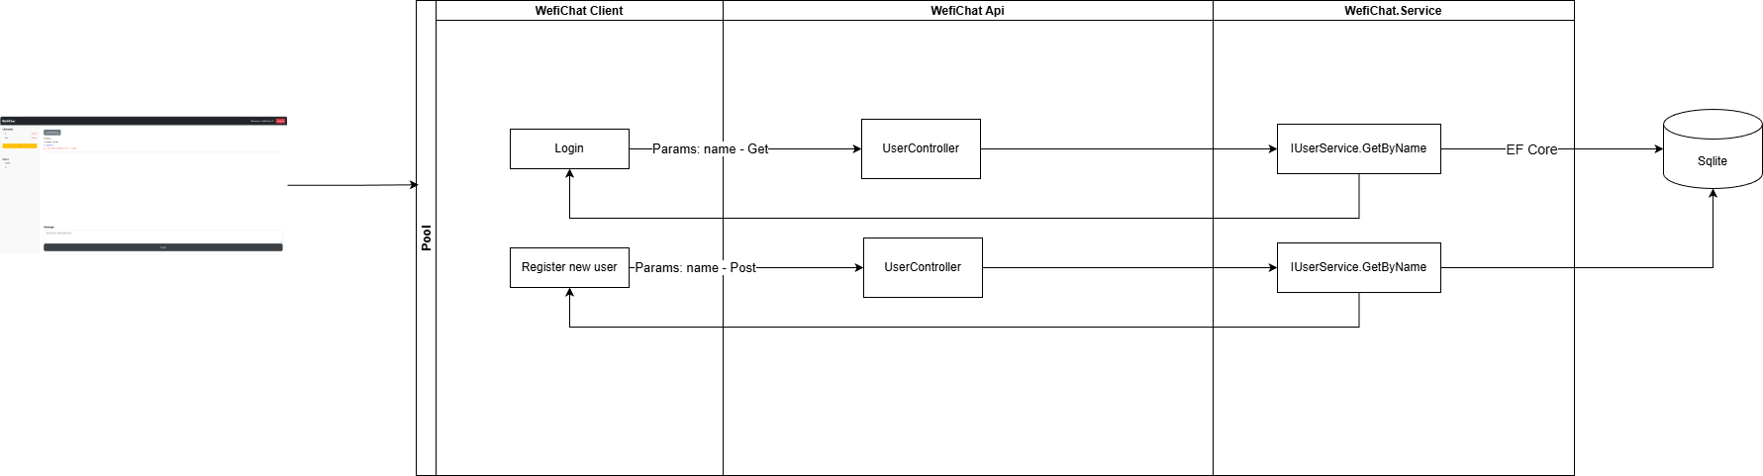
fig 8. Activity diagram

Outstanding steps
1. Add better logging.
2. Improve on validation.
3. When application evolve, consider adding caching.

